**FITNESS ROUTINE PLANNER APP**

**i)HOME PAGE:**

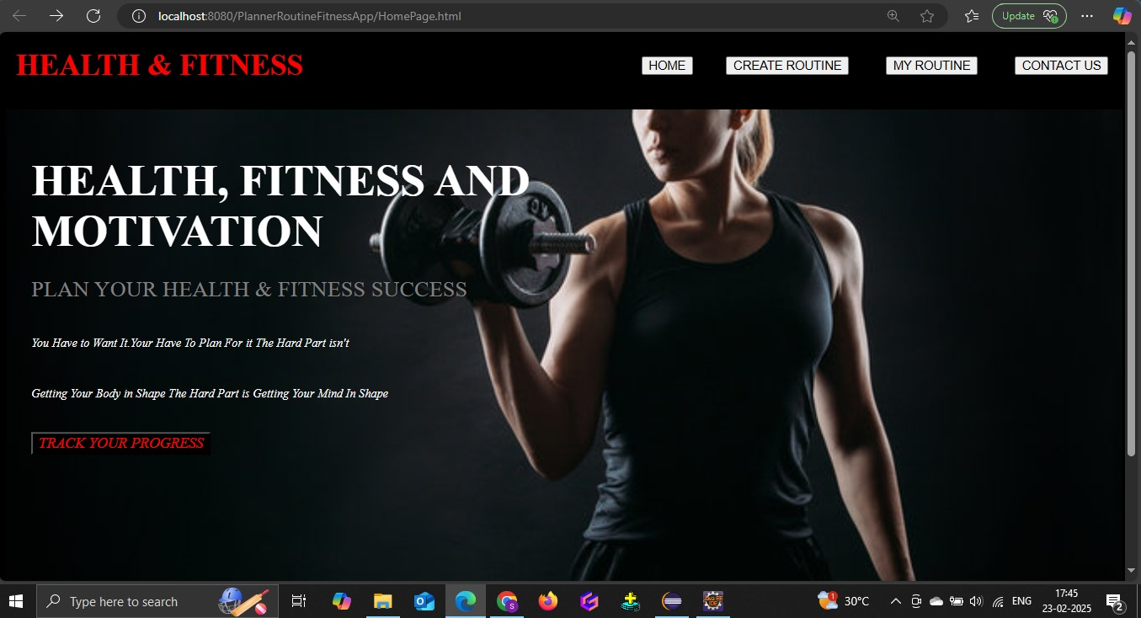

**ii)CREATE ROUTINE PAGE:**

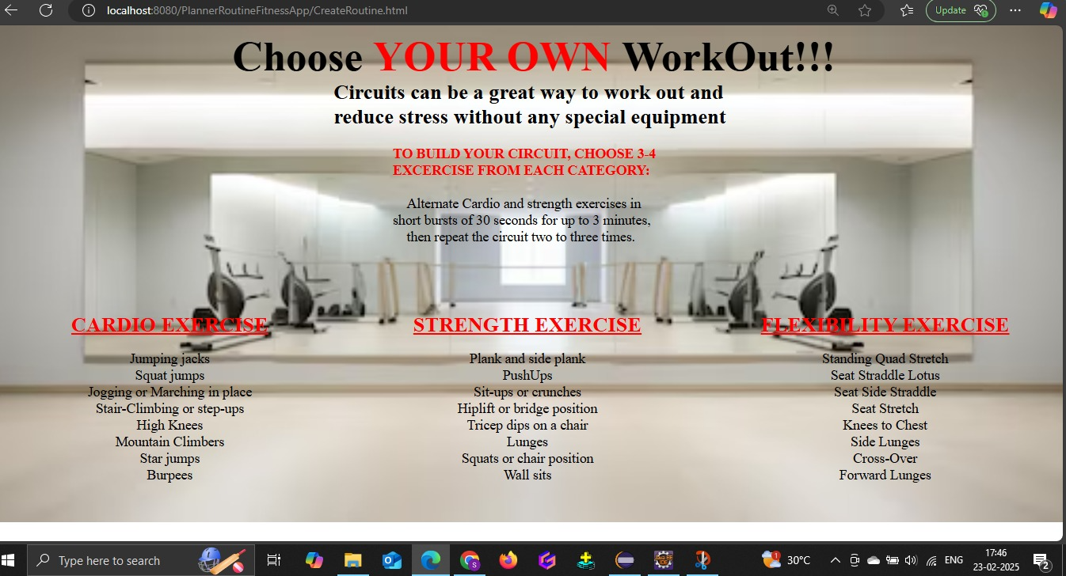

**III)MY ROUTINE:** 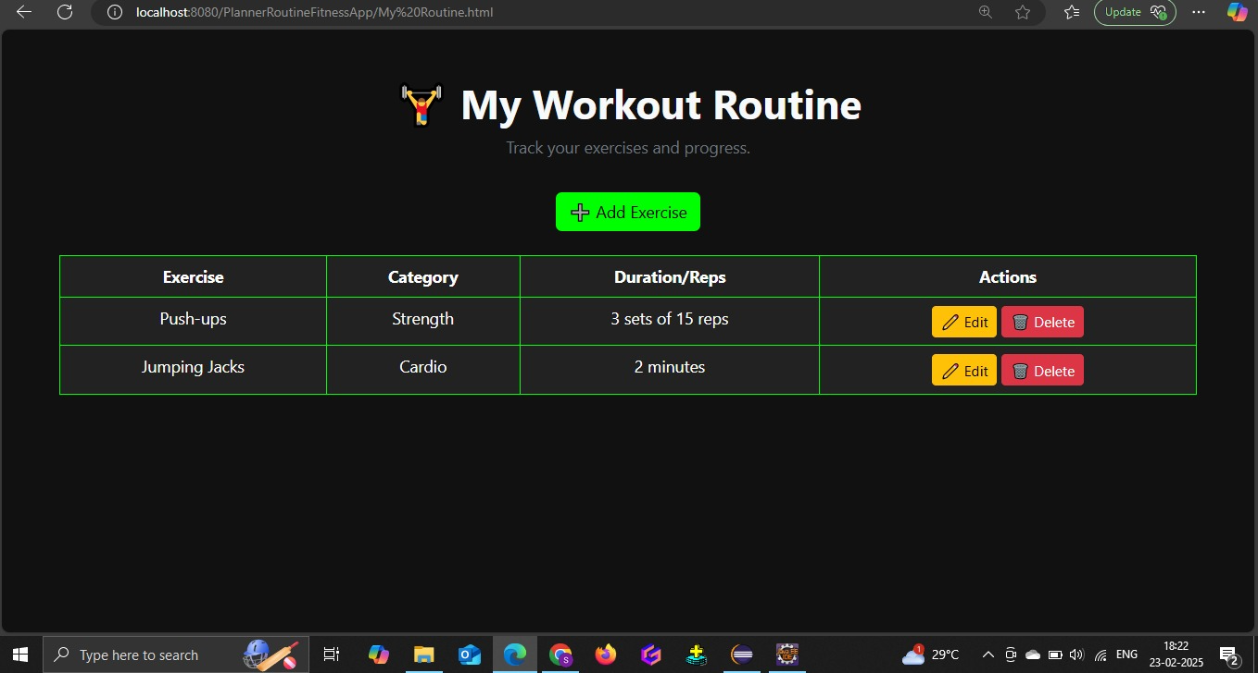

**IV)ADDING EXERCISE:**

